Special Educational Needs Policy
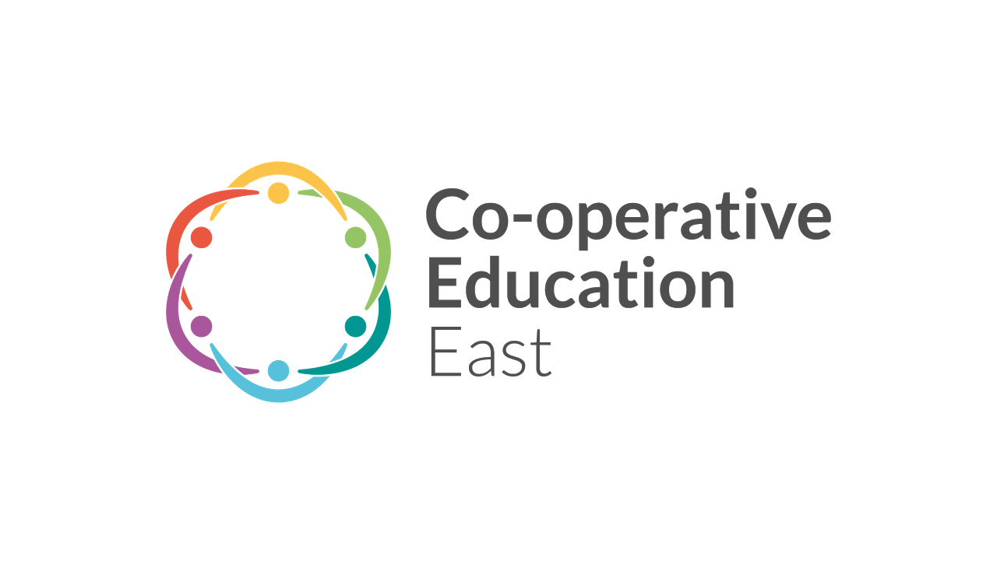

October 2025

Implementation date: October 2025
Review date: October 2026

Banham Primary School

Bunwell Primary School

Thompson Primary School

SPECIAL EDUCATIONAL NEEDS POLICY
This policy should be read in conjunction with The Code of Practice, The SEND Information Report and the following:
- Equality Policy;
- Accessibility Plan;
- Assessment for Learning;
- Anti-Bullying Policy;
- Medical Needs Policy.

LEGISLATION AND GUIDANCE
- This policy is based on the statutory Special Educational Needs and Disability (SEND) Code of Practice and the following legislation:
- Part 3 of the Children and Families Act 2014, which sets out schools’ responsibilities for pupils with SEN and disabilities
- The Special Educational Needs and Disability Regulations 2014, which set out schools’ responsibilities for education, health and care (EHC) plans, SEN co-ordinators (SENCOs) and the SEN information report

DEFINITIONS
A pupil has SEN if they have a learning difficulty or disability which calls for special educational provision to be made for them.
They have a learning difficulty or disability if they have:
- A significantly greater difficulty in learning than the majority of the others of the same age, or
- A disability which prevents or hinders them from making use of facilities of a kind generally provided for others of the same age in mainstream schools.

Special educational provision is educational or training provision that is additional to, or different from, that made generally for other children or young people of the same age by mainstream schools.

OUR AIM
At Banham, Bunwell and Thompson Primary Schools we currently provide additional and/or different provision for a range of needs. The purpose of identification is to work out what action the school needs to take, rather than to fit a child into a category. It is often found that children’s needs do not fit neatly into one category or area and their needs can overlap significantly into several areas. These needs can also change over time.

The areas of difficulties are identified by the SEN Code of Practice 2014 as:
- Communication and Interaction (C&I)
- Cognition and Learning (C&L)
- Social, Mental and Emotional Health(SEMH)
- Physical and/or Sensory (PS)

At Banham, Bunwell and Thompson Primary Schools we are committed to provide all children, including those with special educational needs and disabilities with a broad and balanced academic and social curriculum which is accessible to all. We ensure that all children are fully included in all aspects of school life and feel equally valued and fully part of the school community.

To achieve this aim:
- We strive to establish a fully inclusive school, eliminate prejudice and discrimination and create an environment where all children can be happy, feel safe and flourish.
- We respond to the children in ways which take account of their varied needs and life experiences.
- We are committed to identifying children’s special educational need/s at the earliest point and then making effective provision to ensure improvement in long term outcomes.
- We aim to work in close partnership with parents and carers to achieve these aims. This includes ensuring parents/carers are able to participate fully in decisions and are provided with information and the support necessary to enable this.
- We support children to participate in discussions and express their views and be fully involved in decisions which affect them.
- We work in close partnership with a range of specialist agencies to enable us to provide effective targeted support.
- We provide support, advice and training for all staff working with children with SEND to enable them to be increasingly able to adapt teaching and resources to respond to the strengths and needs of all children.
- We employ a qualified Special Needs Coordinator who will have responsibility for the day to day operation of the SEN policy and coordination of specific provision made to support individual pupils with SEND, including those who have EHC plans.

ROLES AND RESPONSIBILITIES
Provision for pupils with special educational needs is a matter for the school as a whole.

Governing Body
The governing body will have the following responsibilities. They will:
- appoint a governor with specific responsibility for SEN:
- have regard to the SEND Code of Practice and should oversee the implementation of the reform and provide strategic support to the head teacher
- publish information on the school’s website about the implementation of the governing body’s or the proprietor’s policy for children with SEN.
- ensure that there is a qualified teacher designated as SENCO.
- cooperate generally with the local authority including in developing the local offer and when the school is being named in an EHC plan.
- ensure that arrangements are in place in schools to support pupils at school with medical conditions.
- publish information about the arrangements for the admission of disabled children, the steps taken to prevent disabled children being treated less favourably than others, the facilities provided to assist access of disabled children, and their accessibility plans.
- ensure that all governors are aware of the school’s SEN provision including the deployment of funding, equipment and personnel.

The Executive Headteacher
The Executive head teacher will have the following responsibilities. They will:
- take overall responsibility for implementing the Code of Practice.
- ensure that the SENCO has adequate time to carry out duties and is able to influence strategic decisions about SEN.
- ensure the wider school community understands the implications of SEN provision for whole school improvement (from governors to classroom teachers and teaching assistants).
- put in place arrangements to ensure parents are regularly engaged in discussions about the progress of their child.
- ensure a process is in place for involving parents and young people in reviewing provision and planning for those currently on school action/plus and any newly identified pupils with SEN.
- report to the governing body how resources are deployed to meet provision.

The Special Educational Needs Co-ordinator (SENCO)
The role of the SENCOs includes:
- oversee day-to-day operation of school’s SEN policy;
- coordinating provision for children with SEN;
- liaise with designated teacher where a Looked after Child has SEN;
- overseeing SEN support plans and ensuring teachers and support staff work closely with parents/ carers to follow a graduated approach to SEN Support;
- advise on use of delegated budget/ other resources;
- liaise with parents of children with SEN;
- maintain links with other education settings and outside agencies;
- liaise with potential next providers of education;
- work with head and governors on Equality Act;
- ensure that SEN records are up to date.
- contribute to the in-service training of staff.

Class Teachers
Class teachers have the following responsibility to:
- provide ‘Quality First Teaching’ and a graduated approach of assess, plan, do, review.
- focus on outcomes for the child: Be clear about the outcome wanted from any SEN support.
- be responsible for meeting special educational needs: Use the SENCO strategically to support the quality of teaching, evaluate the quality of support and contribute to school improvement.
- have high aspirations for every child: Set clear progress targets for children and be clear about how the full range of resources are going to help reach them.
- work in partnership with children and parents/carers in planning and reviewing progress, seek their views and provide regular updates on progress.

SEN Support Staff
Class teachers work with SEN support staff to plan effective provision for pupils with SEN. Effective liaison between support staff and class teachers is essential to ensure planned activities are linked to targets set out in support plans.
- TAs are part of the whole school approach to SEN working in partnership with the class teacher and the SENCO to deliver pupil progress and to narrow gaps in performance.
- The support they give should be focused on the achievement of specific outcomes within the graduated approach to SEN support agreed with parents in the context of high-quality teaching overall.
- TAs can be part of a package of support for the individual child but should never be a substitute for the teacher’s involvement with that child.

IDENTIFICATION OF SEN
We are committed to ensuring that all children have access to learning opportunities and for those who are at risk of not making progress, we will intervene. Only the children who need provision that is additional to and/or different from that which is offered in class in order to overcome the barrier to the learning will be identified as having SEN. When a child is identified as having SEN they will be placed on the SEN record as requiring SEN support.

In order to identify the children who, have SEN we follow a range of procedures, which include:
- Discussions with parents/carers
- Discussion with other settings, such as nurseries, childminders or playgroups
- Classroom observations
- Targeted programmes set by the teacher to address the areas posing difficulty
- Monitoring work and progress over time through pupil progress meetings
- Assessment data tracking system (Pupil Asset)
- Evaluating the impact of any adjustments that have been made for the child
- Working with the child and parents/carers to identify strengths and barriers to learning to consider the best way to build on these strengths and overcome barriers to learning.
- The use of a range of assessment materials that have been purchased by the school that can be used to identify strengths and areas of difficulties.

If necessary the SENCO, in partnership with parents/carers and the child, may refer to outside agencies for additional support and advice.

RECORDING SEN
At Banham, Bunwell and Thompson Primary School we have processes that we use in order to assess, monitor and review the support that is given to children who have been identified as having SEN and/or a disability.

SEN/Disability Record – Children who have been identified as having SEN and/or a disability are, with the agreement of the child’s parents/carers, recorded on the school’s SEND record. The record includes the child’s name, date of birth, barriers to learning and the agencies that are involved in their support. This record is kept to ensure that we can monitor the children’s progress effectively. We monitor and review the children’s needs regularly and as the child’s needs change it may mean that they no longer need to be on the record. If this is the case, then we speak to the child’s parents/carers about this.

In Class Support Sheet – These are done at the beginning of each new academic year by the class teacher with each child who has been identified as having SEN and/or a disability and are reviewed termly. This sheet identifies the adjustments and support given to individual children to help support their learning in class.

7Cs Learning Portfolio – An individual portfolio is written and reviewed termly for some children who have been identified as having SEN and/or a disability. The plan outlines areas of need and identifies how these needs will be met. Not every child identified as having SEN and/or a disability will need one of these plans and they are only written, where it is deemed relevant and meaningful.

Provision Map – This identified the provision/interventions offered to children who have been identified as having SEN and/or a disability. It is reviewed and updated termly.

Intervention monitoring sheet – Some children who have been identified as having SEN and/or a disability will take part in small group and/or individual interventions. The progress the children make is monitored and the impact of the intervention is assessed.

INDES - INDES are a framework of standardised terms, co-produced and facilitated by Norfolk County County’s Inclusion and SEND team. There are seven specific sections which describe SEND needs. This framework is used to identify and describe the needs of the children on the SEN record.

Transfer of Information – When a child moves into a new class or leaves the school the transfer of information will be the responsibility of the SENCO.

REFERAL FOR EDUCATION, HEALTH AND CARE ASSESSMENT
The majority of children and young people who have SEN or disabilities will have their needs met within the school. A small percentage of children and young people with significant and/or complex needs may require an Education, Health and Care needs assessment in order for the local authority to decide whether it is necessary for it to make provision in accordance with an EHC plan (EHCP).

To inform this decision the local authority will expect to see evidence of action taken by the school. These include:
- Records of regular interventions, strategies, reviews and their outcomes;
- The pupil’s health including the child’s medical history where relevant;
- Early Learning Goals and National Curriculum levels of attainment in reading, writing and mathematics;
- Educational and other assessments, for example from an advisory specialist support teacher or an educational psychologist;
- Views of the parents/carers and of the child;
- Involvement of other professionals such as health, social services or education welfare service.
- Costed provision maps

EDUCATION, HEALTH AND CARE PLAN (EHCP)
An EHCP includes the following and will be reviewed annually:
- The pupil’s name, address and date of birth;
- Details of all of the pupils’ special needs, including health needs;
- Identification of the special educational provision necessary to meet the pupil Special Educational Needs;
- Short term targets for the child to work towards;
- Identification of the type and name of the school where the provision is to be made;
- Relevant non-educational needs of the child;
- Information on non-educational provision;
- Reports and views of any other specialist involvement.

All children with EHCP will have short-term targets set for them that have been established after consultation with parents, and the child. An EHCP will be reviewed annually and will last until the child is 25, or all targets are met.

ANNUAL REVIEWS
It is a statutory requirement for children with an EHCP to have an Annual Review. At Banham, Bunwell and Thompson Primary School we hold annual reviews for children with an EHCP and termly reviews for those on SEN support.
During these reviews, feedback is given about a child’s progress and new targets are agreed where necessary.

STAFF TRAINING
The school makes an annual audit of training needs for all staff considering school priorities as well as personal and professional development. The school is allocated funding from the Standards Fund each year which it may use to meet identified needs. Particular support will be given to Newly Qualified Teachers and other new members of staff.

POLICY MONITORING AND EVALUATION
The implementation of this policy will be monitored by the head teacher and SENCO. It will be
reviewed annually.

Date of Implementation: October 2025
Date of Review: October 2026
This policy was approved on the 6th November 2025 by the Trustees
Signed Executive Headteacher: M. Gamble
Signed SENCO: K. Brookes
Signed SEN Governor: J. Montagner

