PREVENT Policy



Co-operative Education East

Banham Primary School
Bunwell Primary School
Approved by: M Gamble |  | Date: October 2025  Approved by Trustees on 6th November 2025
Last reviewed on: | 5th October 2023 by Governors
Next review due by: | October 2026
Thompson Primary School

This Preventing Radicalisation Policy is part of our commitment to keeping our pupils and the school community safe. Since the Education and Inspections Act 2006 schools have a duty to promote community cohesion. Over the last few years, global events have led to a growth of extremist viewpoints, including advocacy of violent extremism.
Schools have an important part to play in both educating children and young people about extremism and recognising when pupils start to become radicalised. In March 2015, new statutory duties were placed on schools by the Counter Terrorism and Security Act 2015 which means they must work to prevent children being drawn into extremism.
Safeguarding children from all risks of harm is an important part of a school’s work and protecting them from extremism is one aspect of that.

Cooperative Education East
At Cooperative Education East we ensure that through our vision, values, relationships and teaching we promote tolerance and respect for all cultures, faiths and lifestyles. The Governors also ensure that this ethos is reflected and implemented effectively through school policy and practice and that there is effective application of safeguarding policies in place to safeguard and promote pupils’ welfare.
We have a duty to prepare our pupils for life in modern Britain and to keep them safe. Everyone at Cooperative Education East has the right to learn and work in safety. Bullying will not be tolerated, of any kind and derogatory language and behaviour towards others will be challenged.

Statutory Guidance
The duty to prevent children and young people being radicalised is set out in the following documents.
- Counter Terrorism and Security Act 2015 - Counter-Terrorism and Security Act - GOV.UK (www.gov.uk)
- Keeping Children Safe in Education 2023 - Keeping children safe in education 2023 (publishing.service.gov.uk)
- Prevent Duty Guidance 2015 - Prevent duty guidance - GOV.UK (www.gov.uk)
- Working Together to Safeguard Children 2015 - Working together to safeguard children - GOV.UK (www.gov.uk)
Non-statutory Guidance
Promoting fundamental British values as part of SMSC in schools: DfE Departmental advice for maintained schools 2014.
Norfolk Schools and Learning Prevent Prevent duty - Schools (norfolk.gov.uk)

Related Policies
- Online Safety Policy
- Behaviour Policy
- Safeguarding Policy
- Equality Opportunities Policy

Definitions
Extremism is defined in the 2011 Prevent strategy as vocal or active opposition to fundamental British values, including democracy, the rule of law, individual liberty and mutual respect and tolerance of different faiths and beliefs. We also include in our definition of extremism calls for the death of members of our armed forces, whether in this country or overseas.
Radicalisation refers to the process by which a person comes to support terrorism and extremist ideologies associated with terrorist groups.
British values are democracy, the rule of law, individual liberty and mutual respect and tolerance of those with different faiths and beliefs.
Roles and Responsibilities
Role of the Governors
It is the role of the Governors to ensure that the schools meet their statutory duties with regard to preventing radicalisation.
The schools have a nominated Safeguarding Governor who will liaise with the Head teacher and other staff about issues to do with protecting pupils from radicalisation.
Role of the Head teacher
It is the role of the Head teacher to:
- ensure that the school and its staff respond to preventing radicalisation on a day-today basis
- ensure that the school’s curriculum addresses the issues involved in radicalisation
- ensure that staff conduct is consistent with preventing radicalisation
Role of Designated Safeguarding Lead
It is the role of the Designated Safeguarding Lead to:
- ensure that staff understand the issues of radicalisation, that they are able to recognise the signs of vulnerability or radicalisation and know how to refer their concerns
- receive safeguarding concerns about pupils who may be vulnerable to the risk of radicalisation or are showing signs of radicalisation
- make referrals to appropriate agencies with regard to concerns about radicalisation
- liaise with partners, including the local authority and the police.

Role of Staff
It is the role of staff to understand the issues of radicalisation, that they are able to recognise the signs of vulnerability or radicalisation and know how to refer their concerns. All staff across the trust take part in annual safeguard training.
Curriculum
We are committed to ensuring that our pupils are offered a broad and balanced curriculum that aims to prepare them for life in modern Britain. We encourage our pupils to be inquisitive learners who are open to new experiences and are tolerant of others. Our values support the development of the whole child as a reflective learner within a safe respectful learning environment. Teaching the trusts’ core values alongside the fundamental British values supports quality teaching and learning, whilst making a positive contribution to the development of a fair, just and civil society.
Internet Safety
The internet provides children and young people with access to a wide-range of content, some of which is harmful. Extremists use the internet, including social media, to share their messages. The NYCC filtering systems used at our schools block inappropriate content, including extremist content.
Where staff, pupils or visitors find unblocked extremist content they must report it immediately to a senior member of staff.
The e-safety and internet user policy refers to preventing radicalisation and related extremist content. Pupils and staff know how to report internet content that is inappropriate or of concern.
Staff Training
Staff will be given training to help them understand the issues of radicalisation, so that they are able to recognise the signs of vulnerability or radicalisation and know how to refer their concerns. This information also forms part of the annual safeguarding training.
Safer Recruitment
We ensure that the staff we appoint to the school are suitable, our recruitment procedures are rigorous and we follow the statutory guidance published in Keeping Children Safe in
Education 2021. DBS checks are carried out in accordance to, up to date guidance on persons having regular unsupervised access to children.
Visitors
Visitors to the schools are made aware of our safeguarding and child protection policies on arrival at the schools and are given information about what to do if they are concerned about any aspect of child welfare. Posters identifying the safeguarding team are on display around the schools.
We undertake due diligence to ensure that visiting speakers are appropriate. Speakers will be supervised at all times and will not be allowed to speak to pupils without a member of staff being present.
Staff must not invite speakers into schools without first obtaining permission from the Head teacher and or CEO.
Signs of Vulnerability
There are no known definitive indicators that a young person is vulnerable to radicalisation, but there are number of signs that together increase the risk.
Signs of vulnerability include:
- underachievement
- being in possession of extremist literature
- poverty
- social exclusion
- traumatic events
- global or national event
- religious conversion
- change in behaviour
- extremist influences
- conflict with family over lifestyle
- confused identify
- victim or witness to race or hate crimes
- rejection by peers, family, social groups or faith
- isolation from peers
- becoming withdrawn in class
- disengagement from work
- aggressive behaviour towards peers
- rebelling against school rules
- attendance – change in pattern
Recognising Extremism
Early indicators of radicalisation or extremism may include:
- showing sympathy for extremist causes
- glorifying violence, especially to other faiths or cultures
- making remarks or comments about being at extremist events or rallies outside school
- evidence of possessing illegal or extremist literature
- advocating messages similar to illegal organisations or other extremist groups
- out of character changes in dress, behaviour and peer relationships (there are also very powerful narratives, programmes and networks that young people can come across online so involvement with particular groups may not be apparent)
- secretive behaviour
- on-line searches or sharing extremist messages or social profiles
- intolerance of difference, including faith, culture, gender, race or sexuality
- graffiti, art work or writing that displays extremist themes
- attempts to impose extremist views or practices on others
- verbalising anti-Western or anti-British views
- advocating violence towards others
Also consider families at risk
- Not buying into schools ethos
- Questioning policies
- Keeping apart from other parents
Referral Process
Staff and visitors to the schools must refer all concerns about pupils who show signs of vulnerability or radicalisation to the Designated Safeguarding Lead using the usual methods for reporting other safeguarding concerns.
Norfolk Practitioners Guide to Safeguarding will be followed should a referral need to be made please see Appendix 1. The formal Norfolk Prevent Referral form will be completed by a DSL and if appropriate class teacher see Appendix 2.

Appendix 1 Norfolk Practitioners’ Quick Guide: Safeguarding Individuals Vulnerable to Radicalisation (VTR) and referral process
VTR - Prevent Norfolk practitioners quick guide - safeguarding individuals vulnerable to radicalisation
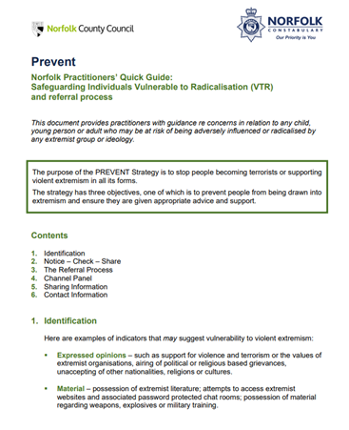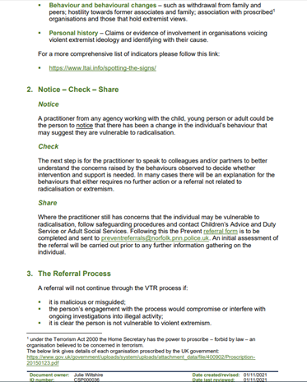
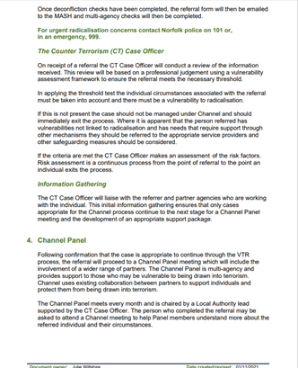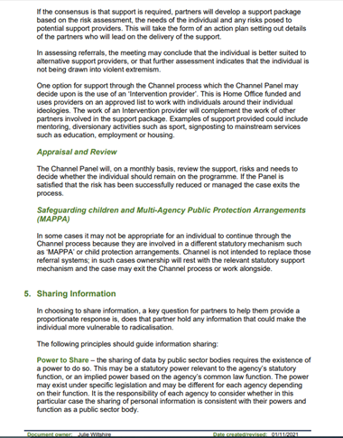
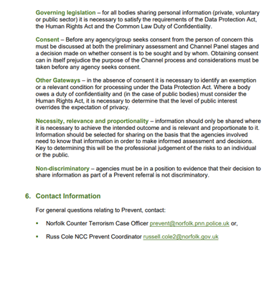

Appendix 2 Norfolk’s Prevent Referral Form

Prevent referral form
By sending this form you consent for it to arrive with both your dedicated Local Authority safeguarding team and Prevent policing team for a joint assessment. Wherever possible we aim to give you feedback on your referral, please be aware, however, that this is not always possible due to data protection and other case sensitivities.
Once you have completed this form, please email it to preventreferrals@norfolk.pnn.police.uk
If you have any questions while filling in the form, please call the Prevent team on 01953 423905 or 01953 423896

Individual’s biographical and contact details
Forename(s):
Surname:
Date of Birth:
Approximate age:
Gender:
Known address(es), identify which address is the individual’s current residence:
Nationality or citizenship:
Immigration or asylum status:
Primary language:
Contact telephone number(s):
Email address(es):
Any other relevant family details such as who lives with the individual:

Describe concerns
In as much detail as possible, please describe the specific concern(s) relevant to Prevent. For example:
· How or why did the individual come to your organisation’s notice in this instance?
· Does it involve a specific event? What happened? Is it a combination of factors? Describe them.
· Has the individual discussed personal travel plans to a warzone or countries with similar concerns? Where? When? How?
· Does the individual have contact with groups or individuals that cause you concern? Who? Why are they concerning? How frequent is this contact?
· Is there something about the individual’s mobile phone, internet or social media use that is worrying to you? What exactly? How do you have access to this information?
· Has the individual expressed a desire to cause physical harm, or threatened anyone with violence? Who? When? Can you remember what was said / expressed exactly?
· Has the individual shown a concerning interest in hate crimes, or extremists, or terrorism? Consider any extremist ideology, group or cause, as well as support for “school-shooters” or public-massacres, or murders of public figures.
· Please describe any other concerns you may have that are not mentioned here in the box below.

Type text here

Complex needs
Is there anything in the individual’s life that you think might be affecting their wellbeing or that might be making them vulnerable in any sense? Please describe, for example:
· Victim of crime, abuse or bullying.
· Work, financial or housing problems.
· Citizenship, asylum or immigration issues.
· Personal problems, emotional difficulties, relationship problems, family issues, ongoing court proceedings.
· On probation; any erratic, violent, self-destructive or risky behaviours, or alcohol or drug misuse or dependency.
· Expressed feelings of injustice or grievance involving any racial, religious or political issue, or even conspiracy theories.
· Educational issues, developmental or behavioural difficulties, mental ill health (see Safeguarding Considerations below).
· Please describe any other need or potential vulnerability you think may be present but which is not mentioned here.

Type text here

Other information
Please provide any further information you think may be relevant for example social media details, military service number, other agencies or professionals working with the individual etc.
Type text here

Person who first identified the concerns
Does the identifier wish to remain anonymous?
Forename:
Surname:
Professional role and organisation:
Relationship to individual:
Contact telephone number:
Email address:

Person making this referral if different from person named above
Forename:
Surname:
Professional role and organisation:
Relationship to individual:
Telephone number:
Email address:

Referrer’s organisational Prevent contact if different from above
Forename:
Surname:
Professional role and organisation:
Relationship to individual:
Telephone number:
Email address:

Relevant dates
Date the concern first came to light:
When were the concerns first identified?
Date referral made to Prevent:
Date this form was completed and sent off:

Safeguarding considerations
Does the individual have any stated or diagnosed disabilities, disorders or mental health issues? Please describe, stating whether the concern has been diagnosed.
Type text here

Have you discussed this individual with your organisations Safeguarding or Prevent lead? What was the result of the discussion?
Type text here

Have you informed the Individual that you are making this referral? What was the response?
Type text here

Have you taken any direct action with the individual since receiving this information? What was the action and the result?
Type text here

Have you discussed your concerns around the individual with any other agencies? What was the result of the discussion?
Type text here

Individual’s employment or education details
Current occupation and employer(s):
Previous occupation(s) and employer(s):
Current educational establishment(s):
Previous educational establishment(s):
Thank you for taking the time to make this referral. Information you provide is valuable and will always be assessed. If there is no Prevent concern but other safeguarding issues are present, this information will be sent to the relevant team or agency to provide the

